**Unveiling the Cosmos: Introducing Outer Space and Inter-Galactic Exploration to The Sims**

**Overview:** Embark on an otherworldly adventure with the latest expansion proposal for The Sims. "Unveiling the Cosmos" aims to introduce a captivating outer space and inter-galactic concept to the game, offering players an unparalleled opportunity to immerse themselves in a universe of limitless possibilities. This expansion not only promises to promote movies and video games through a customized world theme but also elevates player interactions to new dimensions.

**Value Statement:** "Unveiling the Cosmos" brings a groundbreaking experience to The Sims community by expanding the virtual horizons beyond Earth. Players will delve into a realm of creativity and discovery, engaging with an entirely new dimension that seamlessly blends popular culture references, personalized storytelling, and the allure of space exploration. By connecting movies, video games, and customized world themes, this expansion adds a unique promotional avenue, fostering a sense of wonder and excitement among players. This endeavor will additionally empower us to generate substantial traction, encompassing both financial gains and the retention of our current user base, while also attracting a broader global audience.

**Solution:** The expansion introduces a cosmic neighborhood accessible through a high-tech observatory in the Sims world. Players can craft their own astronaut avatars, customize space-themed homes, and embark on spacefaring adventures. This celestial destination will also feature iconic landmarks inspired by popular movies and games, providing a dynamic platform for cross-promotion. From stargazing parties to inter-galactic trade, the expansion offers an array of activities, fostering engagement and encouraging players to create narratives that transcend the terrestrial.

To achieve this, we will leverage the current Manage Worlds game mechanics. Through OTA updates, we can seamlessly introduce additional options that offer tailored worlds, each designed to align with specific promotional events. For instance, consider the scenario of a Zack Snyder Justice League movie promotion, where players can personalize their worlds to reflect either a post-apocalyptic setting or a celebratory environment where heroes emerge victorious. This will involve an extension of the existing player costume customization classes, alongside the introduction of a new feature in the environment settings enabling weather adjustments. This latter addition, a short-term asset, will serve the promotional duration. To enhance the network experience, we propose a dual approach. Players will have the flexibility to download assets in either maximum settings for optimal visual quality or opt for a low-resolution version, requiring less network and device bandwidth. Furthermore, to streamline gameplay and conserve memory, we intend to incorporate a caching mechanism as part of the serving layer, effectively alleviating the memory load on players' devices.

Furthermore, we can connect this concept to inter-world competition or invasion modes, creating a setup in which teams can either conquer or defend their world on a larger scale. We can introduce various elements to enhance the experience, such as temporary outer shield protection, aerial weaponry provided by conquering teams, and a galactic-level attack mechanism. Let's just Imagine that we're running a movie campaign centered around a storyline featuring a colossal monster akin to Godzilla. This monstrous creature confronts relentless external threats and ultimately becomes the savior of the world. We can transform and embellish the Sims world to mirror this narrative, creating an enriched and immersive gameplay experience.

**Evaluation Statement:** The evaluation strategy for the real-world implementation of the "Unveiling the Cosmos" expansion encompasses a practical approach that considers both the project's current stage and its potential benefits and challenges. By utilizing a diverse range of assessment methods, we aim to ensure its success while navigating the intricacies of the real gaming landscape. Among the advantages, the evaluation emphasizes improved engagement metrics, analyzing player interaction frequency and depth in space-themed activities to gauge the expansion's appeal. The cross-promotion's effectiveness will be assessed through player interaction with integrated movie and video game content, creating opportunities for mutual promotion. Player feedback is a crucial driver of refinement, allowing the expansion to align better with user preferences. Moreover, the extension of player sessions and the attraction of a global audience through engaging promotional events are key indicators of success. However, recognizing potential challenges is equally important. Technical complexities might arise, necessitating robust infrastructure and regular performance checks. Content management efficiency can be achieved through strategic planning and streamlined processes. Gameplay balance and user transition concerns can be managed with playtesting and gradual introductions, while a thoughtful monetization strategy ensures ethical player engagement. With proactive community management and continuous marketing assessment, the expansion can thrive in the dynamic gaming environment, reaping the benefits while addressing challenges effectively. Additionally, we must address the need for optimization to accommodate the demanding graphics requirements that could potentially result in slower gameplay on less powerful devices. To overcome this challenge, our focus will extend to the networking layer and even encompass a global cache level, seeking effective solutions to ensure a smooth gaming experience across various device types.

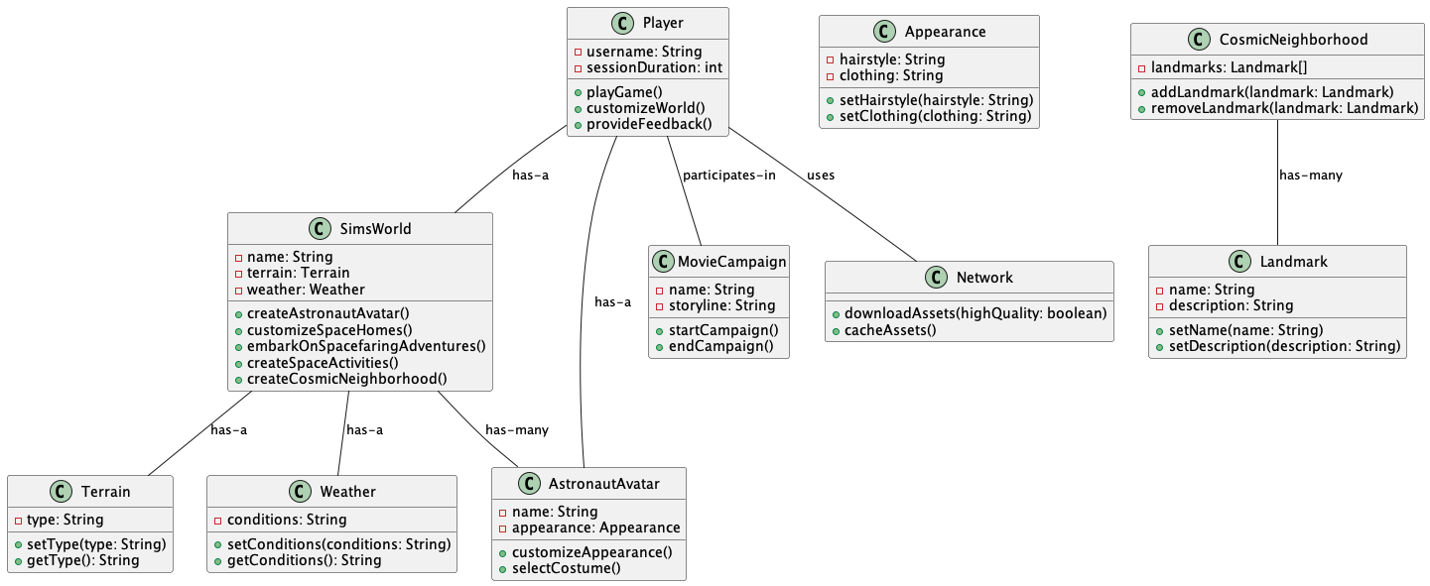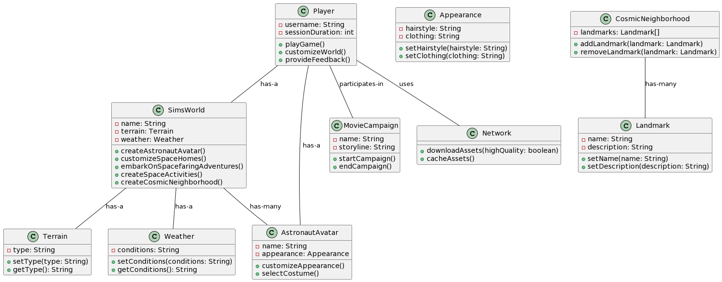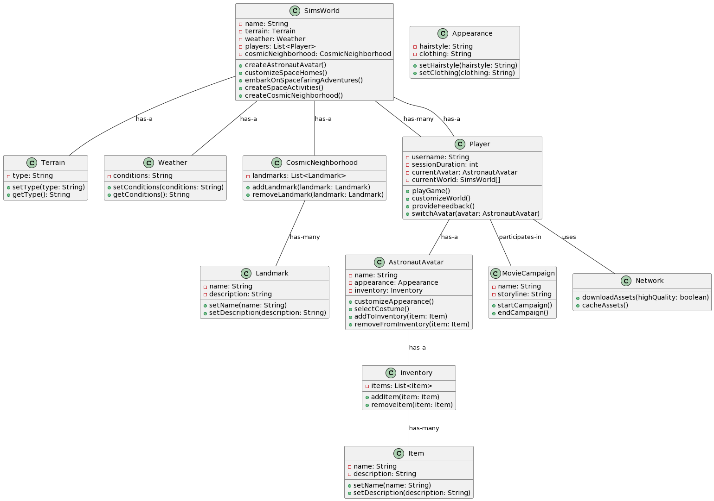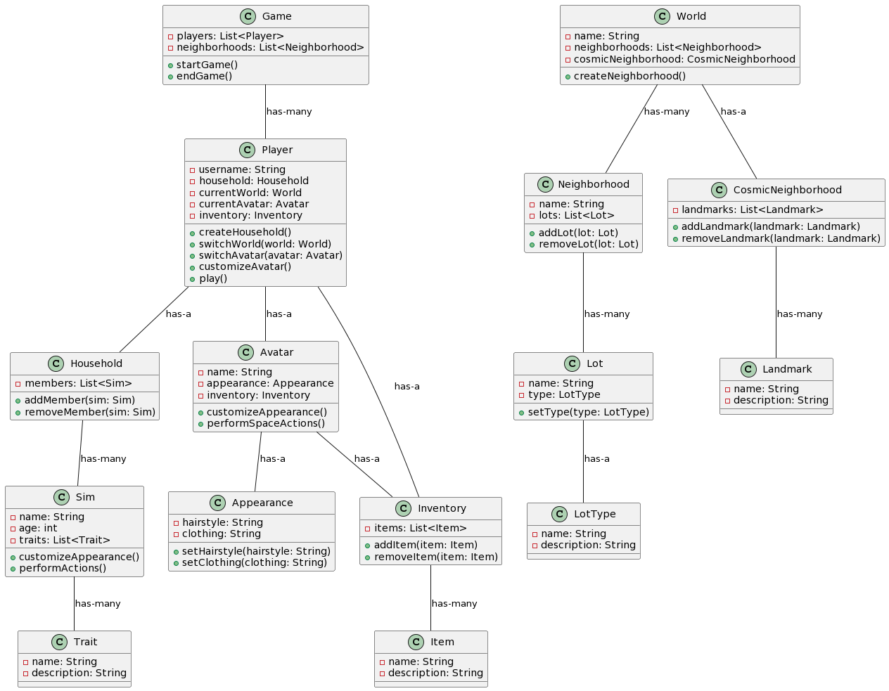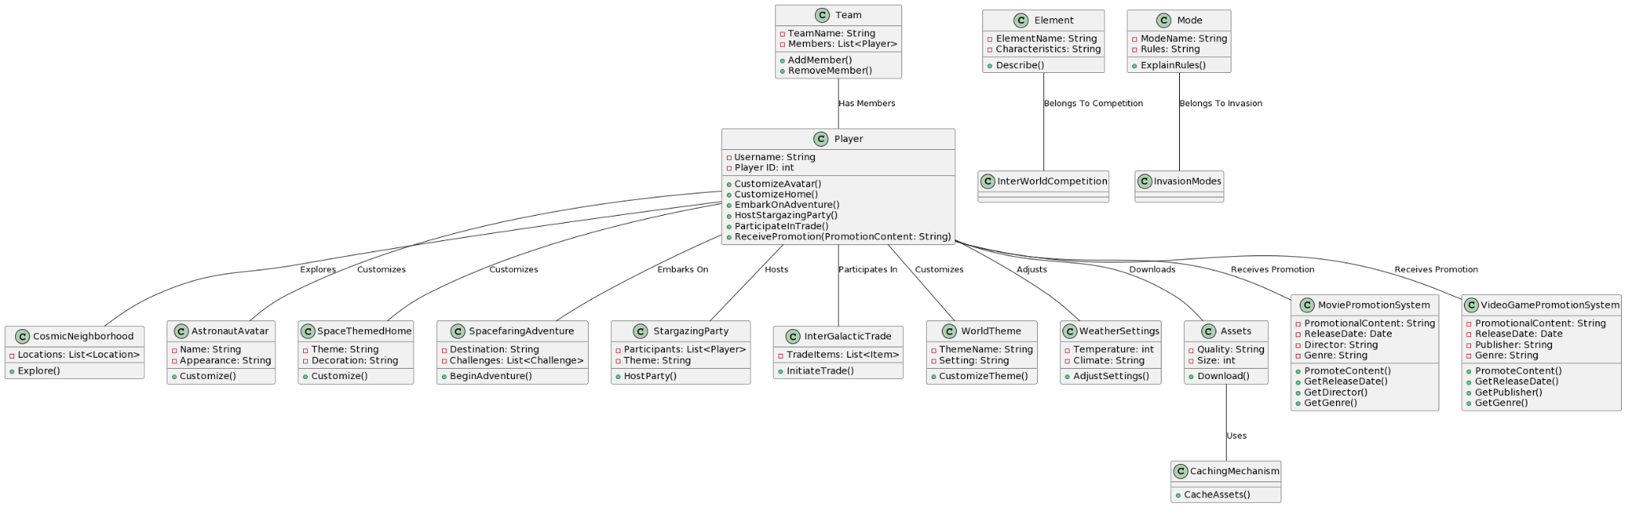

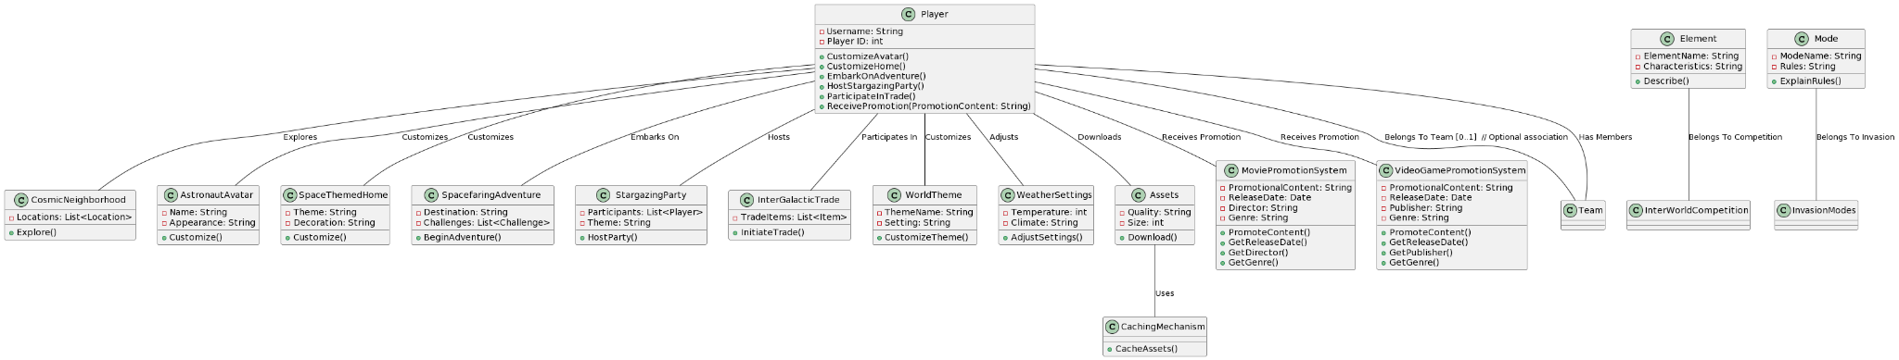

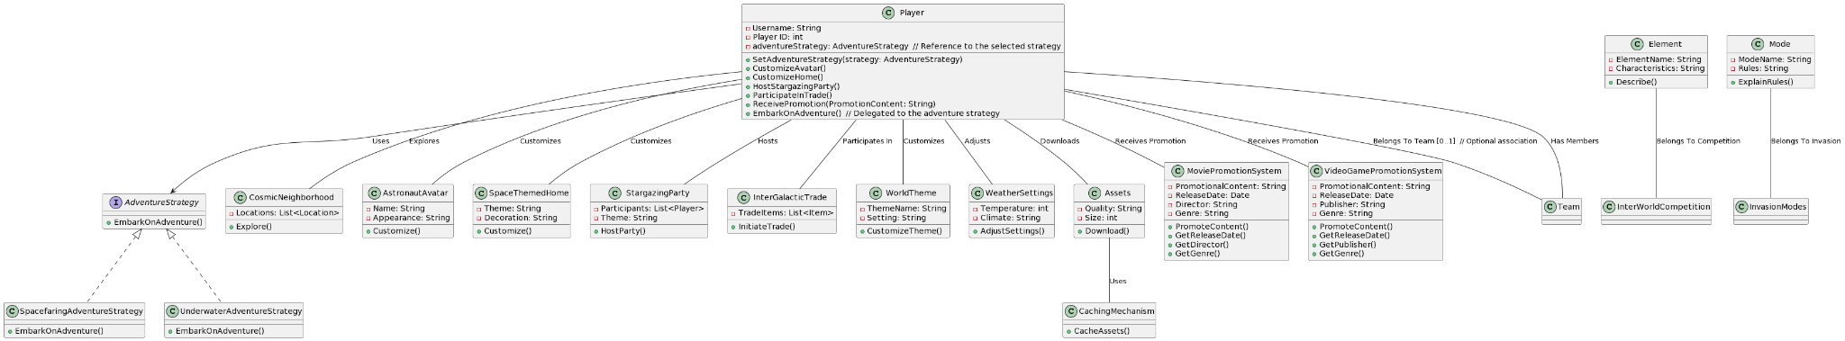

The class diagram above describes a design pattern known as the "Strategy Pattern."

In the Strategy Pattern, you define a family of algorithms, encapsulate each one of them, and make them interchangeable. In your UML diagram:

1. `AdventureStrategy` is an interface that defines the strategy contract.

2. `SpacefaringAdventureStrategy` and `UnderwaterAdventureStrategy` are concrete classes that implement the `AdventureStrategy` interface, representing different adventure strategies.

The `Player` class has a reference to the `AdventureStrategy` interface through the `adventureStrategy` attribute. This allows the `Player` to dynamically change its adventure strategy at runtime by calling `SetAdventureStrategy`.

This pattern enables you to change or switch between different adventure strategies without altering the `Player` class itself. It promotes code flexibility and maintainability by separating the algorithm (strategy) from the context (the `Player` class).

So, the design pattern being used here is the "Strategy Pattern."

OOPs concepts used:

The class diagram you've provided incorporates several major object-oriented concepts. Here are some of the key concepts and principles used in this diagram:

* Classes and Objects:
  + The diagram includes various classes such as Player, CosmicNeighborhood, AstronautAvatar, and others, which represent the blueprint for creating objects.
* Inheritance:
  + The relationships denoted by the arrows with solid lines (e.g., AdventureStrategy <|.. SpacefaringAdventureStrategy) represent inheritance. The SpacefaringAdventureStrategy and UnderwaterAdventureStrategy classes inherit from the AdventureStrategy interface.
* Abstraction:
  + The use of interfaces (e.g., AdventureStrategy) and abstract classes (not explicitly shown but implied by the interface) represents abstraction. It allows you to define common behaviors and ensure that concrete classes implement them.
* Encapsulation:
  + The class attributes are private (e.g., Username, Player ID) and can only be accessed through public methods (getters and setters), demonstrating the concept of encapsulation. The encapsulation of attributes helps maintain data integrity.
* Polymorphism:
  + Polymorphism is achieved through the use of the AdventureStrategy interface. The Player class can work with different concrete strategy implementations interchangeably due to the shared interface.
* Association:
  + Associations between classes, represented by lines connecting classes, show how different classes are related or interact with each other. For example, Player has associations with various other classes, indicating how it relates to them.
* Aggregation and Composition:
  + Aggregation and composition relationships are not explicitly indicated in the diagram, but they could be inferred based on the context. Aggregation represents a "whole-part" relationship, while composition represents a stronger form of aggregation where the part cannot exist without the whole.
* Dependency:
  + Dependencies between classes indicate that one class relies on another, but it does not own the other class. For example, the Player class depends on the AdventureStrategy interface, which is a form of dependency.
* Optional Association:
  + The optional association (e.g., Player -- Team : Belongs To Team [0..1]) demonstrates multiplicity and optional relationships between classes.
* Single Responsibility Principle (SRP):
  + Classes are designed with a single responsibility or purpose. For example, AstronautAvatar is responsible for customizing avatars, and SpaceThemedHome is responsible for customizing homes. This adheres to the SRP, a part of SOLID principles.
* Composition of Objects:
  + Certain classes, like StargazingParty and InterGalacticTrade, contain lists or collections of other objects (e.g., Participants and TradeItems). This represents the composition of objects.
* Association and Aggregation Roles:
  + Roles and multiplicities (e.g., Player -- Team : Belongs To Team [0..1]) are used to specify how different classes are related in terms of associations.

These are some of the major object-oriented concepts and principles illustrated in the class diagram you've provided. They help structure and design the software system in an organized and maintainable way.